AWS IAM USER
& BILLING ALERTS
Step-by-step practical documentation

Task: Create an IAM user for programmatic access, save its access-key pair securely, and configure email notifications for AWS Free Tier usage and estimated charges.

Important observation from the supplied screenshots
The screenshots document creation of an IAM user named “bobbbbyyyy” (as displayed) with the “Provide user access to the AWS Management Console” option checked and a custom console password. Therefore, the user shown was NOT created as programmatic-access-only. The screenshots also do not show an access-key pair being generated or downloaded. The steps below explain how to correct/configure this and clearly distinguish completed evidence from steps still to perform.

Prepared from the five screenshots supplied

1. Aim
To create an AWS Identity and Access Management (IAM) user intended for programmatic access, generate and securely download the Access Key ID and Secret Access Key, and configure email alerts so that the account owner is notified when AWS Free Tier usage approaches its limits or account charges reach a chosen threshold.

2. Requirements
- An AWS account with permission to manage IAM users and billing preferences.
- A valid email address that can receive AWS notifications.
- A web browser and internet connection.
- A secure location (such as an approved password manager) to store the access-key CSV file.

3. Create an IAM user
The supplied screenshots show the following creation workflow:
- Open the AWS Management Console and search for IAM.
- In the IAM navigation pane, select Users. The initial screen showed zero IAM users.
- Choose Create user and enter a unique user name.
- For a programmatic-access-only user, leave “Provide user access to the AWS Management Console” unchecked. Do not create a console password.
- Choose Next and assign only the permissions required for the intended task. Prefer adding the user to a group with a least-privilege policy rather than granting broad administrator permissions.
- Review the details and choose Create user.
Correction needed for the user shown in the screenshots
In the supplied User details screenshot, the console-access checkbox is selected and a custom password is entered. To make this user programmatic-only, remove/disable its console sign-in profile (or create a separate IAM user with console access unchecked). Then create an access key under that user’s Security credentials tab. Do not share the console password or access keys.

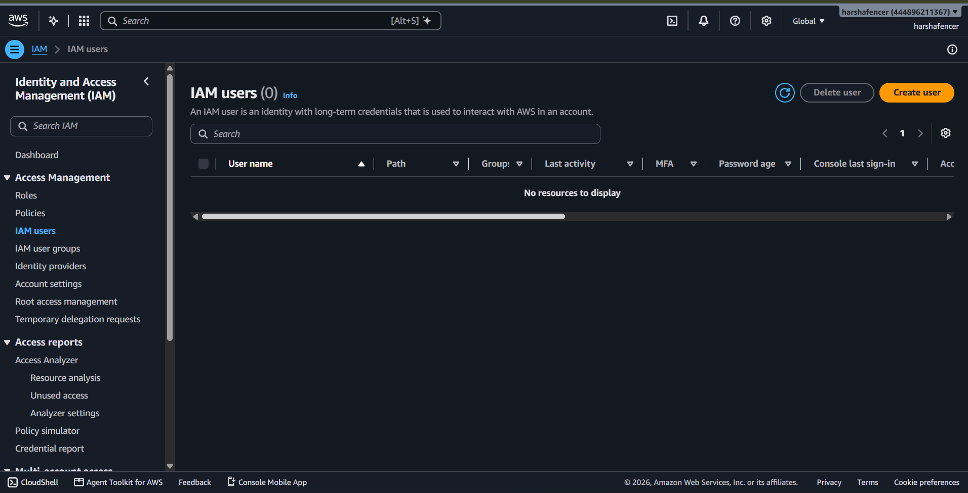
Figure 1. IAM Users page before creation — no IAM users were listed.
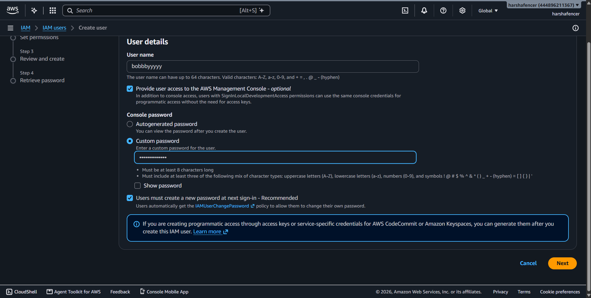
Figure 2. User details — username entered; console access is visibly enabled in this screenshot.
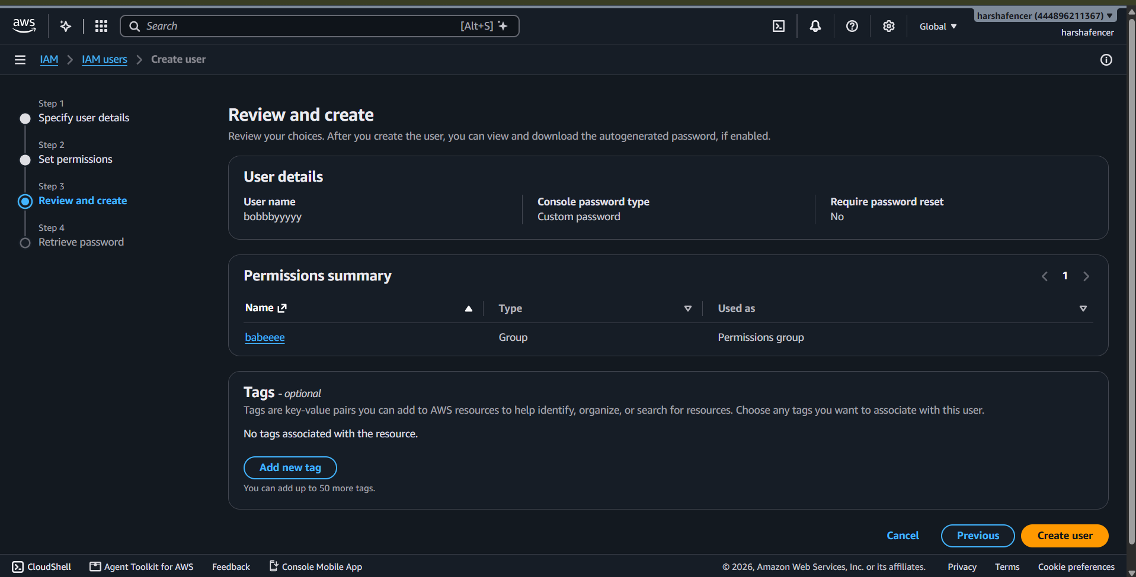
Figure 3. Review and create — the selected permissions group is shown in the review summary.
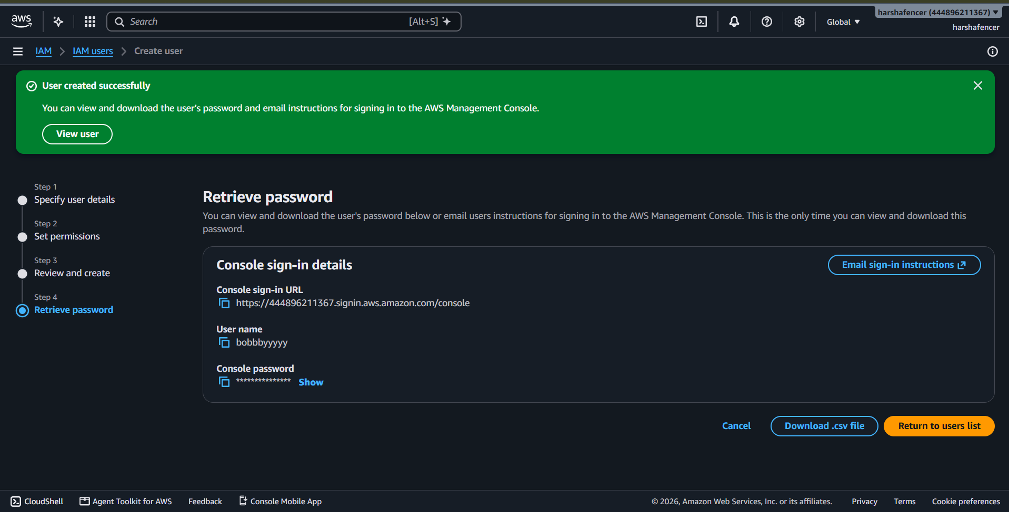
Figure 4. AWS confirms that the IAM user was created successfully. The page displays console sign-in details, not programmatic access keys.

4. Generate and download the programmatic access keys
An IAM access-key pair is used by the AWS CLI, SDKs, or applications to sign programmatic requests. AWS recommends temporary credentials/roles where possible; create a long-term IAM access key only when the use case requires it.
- Open IAM → Users and select the newly created IAM user.
- Open the Security credentials tab.
- Scroll to the Access keys section and choose Create access key.
- Review the access-key best-practice information. If a long-term key is genuinely required, select the use case that best matches the task (for a generic learning or external-tool use case, AWS may offer “Other”), then choose Next.
- Optionally enter a description tag, such as “local-development”, and choose Create access key.
- On the Retrieve access key page, reveal the Secret Access Key if needed and choose Download .csv file.
- Store the CSV in a secure password manager or other protected secret store. Do not upload it to GitHub, include it in source code, email it, or share it in screenshots.
One-time secret-key visibility
AWS displays the Secret Access Key only when the key is created. Download the CSV immediately. If the secret is lost, it cannot be viewed again; deactivate/delete the old key and create a replacement.

Expected result: the IAM user has an active Access Key ID and Secret Access Key for programmatic authentication. The key ID may be listed later, but the secret value will not be shown again.

5. Configure AWS Free Tier email alerts
- Open Billing and Cost Management in the AWS Console.
- In the navigation pane, open Billing preferences.
- Find Alert preferences and choose Edit.
- Enable “Receive AWS Free Tier usage alerts” (wording may appear as “Receive AWS Free Tier alerts” depending on the console experience).
- Enter an additional email address if the console offers that field, then choose Update.
- Check the inbox and spam/junk folder for AWS notifications. If AWS requires verification for an added recipient, complete the verification.
Free Tier usage alerts are intended to notify the account contact when usage approaches or exceeds Free Tier limits. AWS documentation notes that 85% Free Tier usage alerts may already be automatically enabled for eligible individual accounts; verify the preference rather than assuming it is enabled.

6. Create a monthly cost budget with email notifications
A Free Tier usage alert and a cost budget serve different purposes. The Free Tier alert tracks eligible service usage; a cost budget sends a notification when actual or forecasted account cost reaches a threshold. Configure both for better coverage.
- In Billing and Cost Management, open Budgets and choose Create budget.
- Choose a cost budget (or Customize/Advanced setup and then Cost budget, depending on the current console layout).
- Set the period to Monthly and provide a unique name, for example “Monthly-Cost-Guardrail”.
- Enter a monthly budget amount in USD that you are comfortable with. Choose a realistic amount for your account; do not assume the Free Tier means every possible service or usage pattern is free.
- Add at least one Actual cost alert at a lower threshold (for example 50% or 80%) and another at 100%. If available, add a Forecasted cost alert so you can be warned before the budget is reached.
- Enter the notification email address and create the budget.
- If AWS sends a verification email to a newly added recipient, open it and verify the address before expecting budget notifications.
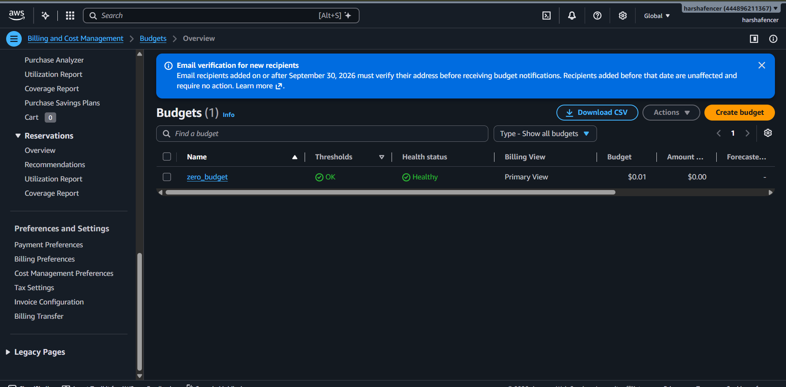
Figure 5. Budgets overview — an existing budget named “zero_budget” is listed with a budget amount of $0.01. This screenshot does not show notification thresholds or email recipients, so it does not prove that an email alert is configured.
Important note about the existing zero_budget
The supplied Budgets overview shows a $0.01 budget and a healthy status, but no alert configuration is visible. A budget amount alone does not prove that an email notification is set up. Open the budget, inspect its Alerts/Notifications section, and add/verify the email recipient and thresholds.

7. Verification checklist
- ☐ IAM user exists in IAM → Users.
- ☐ Console sign-in is disabled for a programmatic-only user.
- ☐ An active access key is listed under Security credentials → Access keys.
- ☐ The access-key CSV was downloaded and stored securely.
- ☐ Free Tier usage alerts are enabled in Billing preferences.
- ☐ A monthly cost budget has been created.
- ☐ Actual and/or forecasted budget thresholds have email recipients configured.
- ☐ Any required recipient email verification has been completed.

8. Security precautions
- Never share the Secret Access Key, console password, or downloaded credentials CSV.
- Never commit credentials to a public or private source-code repository.
- Use least-privilege IAM permissions; avoid attaching AdministratorAccess unless it is genuinely necessary.
- Prefer IAM roles and temporary credentials for workloads that support them.
- Deactivate and delete unused or exposed access keys immediately.
- Review AWS Budgets and Free Tier usage regularly; alerts are notifications, not a hard spending cap and may not prevent charges.

9. Conclusion
The supplied evidence confirms that an IAM user was successfully created and that an AWS budget exists. However, the screenshots show console password access enabled and do not show access-key generation or email-alert configuration. To satisfy the exact task, disable console sign-in for the intended programmatic-only user, generate and securely download its access-key pair, enable Free Tier usage alerts, and configure verified email notifications on a monthly cost budget.

10. Official AWS references
- Create an IAM user: https://docs.aws.amazon.com/IAM/latest/UserGuide/id_users_create.html
- Create/manage IAM user access keys: https://docs.aws.amazon.com/IAM/latest/UserGuide/access-keys-admin-managed.html
- AWS Billing preferences and Free Tier alerts: https://docs.aws.amazon.com/us_en/awsaccountbilling/latest/aboutv2/billing-pref.html
- Track AWS Free Tier usage: https://docs.aws.amazon.com/awsaccountbilling/latest/aboutv2/tracking-free-tier-usage.html
- Create a usage budget / configure notifications: https://docs.aws.amazon.com/cost-management/latest/userguide/create-usage-budget.html

